**Target Compound Screening (TCS) for Drugreprurposing scores for all pairs of proteins in the test set**

Figure 1 RFPP percentiles across proteins for target compound screening using SuperDRUG2 for a random predictor, CPINN and the proposed model trained over different class rations (1:1, 1:3, 1:5 and 1:7)

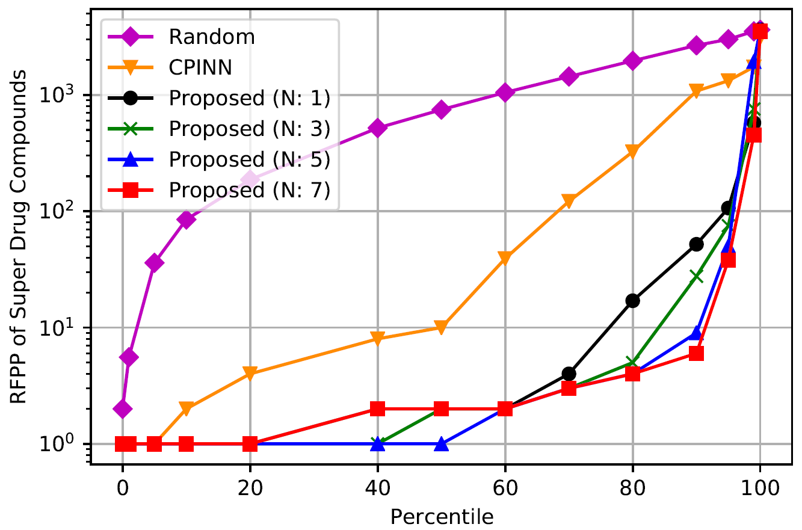

The file can be accessed through this link which has Protein sequence, sorted scores, sorted names, and sorted labels according to the prediction of our model.

[**https://docs.google.com/spreadsheets/d/1sfoRXc8503XZTtT3VA5nQzg1eHA2Dy86/edit?usp=sharing&ouid=111221555398385573178&rtpof=true&sd=true**](https://docs.google.com/spreadsheets/d/1sfoRXc8503XZTtT3VA5nQzg1eHA2Dy86/edit?usp=sharing&ouid=111221555398385573178&rtpof=true&sd=true)